Internet Security Solutions: Firewall, Intrusion Detection System Evaluation in a Virtual Lab Environment

Charan Teja Badavath
50972929
M.S in Applied Digital Technology (Cloud & Cybersecurity)
Course: Directed Individual Study, CRN -6093
Neil Griffin College of Business
Arkansas State University

Faculty Advisor: Dr. James McGinnis
February 27, 2026

Table Of Context
1. Abstract …………………………………………………………………………………………. 1
2. Introduction ……………………………………………………………………………………... 1
3. Methodology ……………………………………………………………………………………. 2
II. Methodology …………………………………………………………………………………… 2
III. Methodology …………………………………………………………………………………... 4
3.1 Research Approach ………………………………………………………………………... 5
3.2 Virtualization Platform ……………………………………………………………………. 6
3.3 Technology: How to configure a Firewall System ………………………………………... 7.
3.4 DNS Configuration is Important.…………………………………………………………. 7
3.4.2 DHCP System and Addressing in Internal Network ……………………………………. 8
3.5 Windows VM Internal IP Configuration …………………………………………………. 8
3.6 Implementation of Intrusion Detection System …………………………………………… 9
3.6.1 IDS Selection …………………………………………………………………………... 9
3.6.2 IDS Implementation and Integration …………………………………………………... 9
3.6.3 Interface monitoring Identification ……………………………………………………... 9
3.7 Testing an attack with Kali Linux ………………………………………………………… 9.
3.8 Results of Scan …………………………………………………………………………… 10
3.9 Verification of Suricata Alerts …………………………………………………………… 10
3.10 System Attacker configuration …………………………………………………………. 10
3.11 Verification of Network Traffic Flow …………………………………………………... 10
3.12 Data Collection Preparation ……………………………………………………………. 10
4. Intrusion Detection Deploy……………………………………………………………………. 11
4.1 Rules of Enabling Emerging Threats (ET Open)
4.2 Development of the Suricata Interface Instance on LAN (em1) ………………………... 12
4.2.1 Explanation Alerts Tab and Logs View …………………………………………… 12
4.2.2 Execution of TCP SYN Scan …………………………………………………….... 13
4.3 Suricata Alert Validation ………………………………………………………………… 15
4.3.1 Logs View and Alerts Tab Explanation
5. Overview Experimental Executive …………………………………………………………… 16
5.1 Network Environment Checking
5.2 Suricata Deployment Checking …………………………………………………………. 16
5.3 Attack Implementation: Nmap TCP SYN Scan ………………………………………… 17
5.4 Suricata Alert Evidence …………………………………………………………………. 18
5.5 Summary Table Experimental Results …………………………………………………... 19
5.6 Analytical Interpretation of Findings
5.7 Final Interpretation of Results ………………………………………………………… 19
6. Port Scan Behaviour of an Internet Host
6.1 The next step is the quantitative analysis of Suricata logs ……………………………. 20
6.2 Quantitative Interpretation
6.3 Why Oddities in the IDS Logs with Port Filtration
6.4 Use of Emerging Threats ET Open Rules ………………………………………….... 21
6.5 Layered Security Model Checking …………………………………………………… 21
6.6 Disadvantages of the Experiment ……………………………………………………... 22
6.7 Academic Interpretation
7. Conclusion …………………………………………………………………………………. 22
7.1 Assessment of Layered Security Model
7.2 Quantitative Alert Analysis
7.3 Security Implications …………………………………………………………………. 23
7.4 Limitations of the Study ……………………………………………………………… 23
8. References ...………………………………………………………………………………… 25

Title
Internet Security Solutions: Firewall, Intrusion Detection System Evaluation in a Virtual Lab Environment.
Abstract
Internet security solutions are firewalls and intrusion detection systems (IDSs), which are typical in defending networks against unauthorized network access and malicious activity. However, such technologies cannot do much until they are well configured and checked. This paper evaluates the security offered by firewall rules and an intrusion detection system against the common attacks on a small network over the Internet. A virtual lab setup is a secure environment that is created using open-source security tools in order to replicate port scanning and brute-force attacks. This paper examines the security provided by firewall rules and intrusion detection systems from some typical attacks against a small network over the Internet using the principles of defense in depth (TechTarget, 2025). Firewall/IDS logs are evaluated in order to figure out whether they have been effective in terms of detection and blocking. The results of this study will show the usefulness of the layered security practices and offer practical advice on how firewalls and IDS can be deployed on the internet-based setting.
Keywords
Internet Security, Firewall, Intrusion Detection System, Cybersecurity, Network Security.
Introduction
Internet infrastructures that are interconnected are becoming more prone to cyberattacks such as port scanning, intrusions, and brute force attacks. These risks are serious threats to the organizational networks, data confidentiality and availability of the services. So, intrusion detection systems and firewalls are commonly used as simple Internet protection.
According to industry experience and other studies, firewalls can be used in traffic management through predefined rules, and invasion detection systems can be used to give an understanding of suspicious actions that may go against firewall-established rules. However, the application of one security mechanism may expose networks to some attack patterns.
This gap will be filled in this paper through the evaluation of the functionality of firewall rules and intrusion detection systems in their combined usage to protect a small network against the common internet-based attacks. The experiment is carried out in a controlled virtual laboratory, and it is possible to perform safe and ethical experiments to simulate the real attack in the real world.
Problem Statement
Although firewalls are widely used as security measures in the protection of internet-based networks, not all malicious activities are detected using a firewall. It is also the use of intrusion detection system as the second layer of security to identify suspicious patterns and attack signatures. This requires a test of firewalls and IDS as integrated solutions to internet security as a unified product.
Research Objectives
The following are the research questions of this paper:
To develop a virtual network that will replicate an environment that is connected to the internet.
To install internet security strategies: a firewall and an intrusion detection system.
To simulate a normal Internet attack in a laboratory setup.
In order to analyse firewall logs and IDS alerts to find the level of detection and blockage.
Scope of the Study
The study is confined to a small virtual laboratory setup based on open-source security. The paper targets basic internet-based attacks, which are port scanning and brute-force attacks. There are more sophisticated persistent threats and enterprise-wide networks that this paper is not discussing.

Tools and Technologies
VirtualBox Virtualization system
pfSense – firewall solution
Snort or Suricata- intrusion detection system.
Kali Linux – attacker system
Windows/ Linux-target system
Methodology
The research will be done in a controlled virtual laboratory environment in accordance with the established practices for experimenting in cybersecurity (Girly-ya, 2025). The laboratory will consist of an attacker machine, a firewall with a built-in intrusion detection system and a target system. The attacker will imitate attacks via the internet and firewall, and IDS responses will be logged in terms of alerts generated.
The protocols, equipment, and procedures involved in the experiment will be well documented in order to guarantee its reproducibility, a key principle of rigorous cybersecurity research (Aleksibovellan, 2024). The methodology is oriented towards transparency and repeatability and, therefore, other researchers can replicate the experiment in similar environments in virtualization (Girly-ya, 2025).
Expected Outcomes
It is anticipated that the final product of this study will prove that the firewall regulations and the intrusion detection mechanism combined are more helpful in keeping the network undefended in the wake of general Internet attacks. It is expected that the findings will reveal the relevance of layered security schemes to Internet security solutions.
Ethical Considerations
The experiments will be conducted in a virtual, isolated environment. No use of public networks, public Wi-Fi, or physical systems will be made. This paper follows the world of ethical cybersecurity research.
II. Methodology
Security and Threats of the Internet/Network.
The research around cybersecurity has been more dedicated to the prevention of network-based attacks on the internet-based systems including port scanning and brute-force authentication efforts. Open services and weak authentication are used to compromise the confidentiality, integrity and availability of the networked systems in such attacks. As the use of the internet gains momentum in organizations and among individuals, it is necessary to understand these threats to develop an effective network security strategy. Figure 1 reveals that the majority of internet-based attacks are external and target publicly accessible services within internal systems.
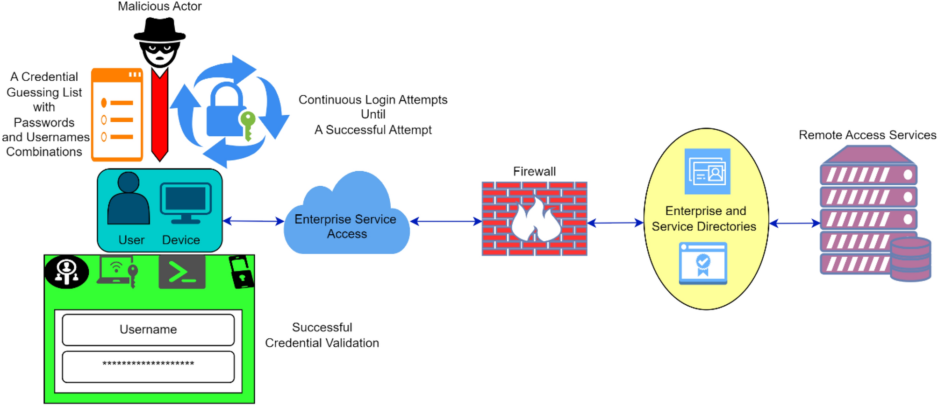
Figure 1.1 Hypothetical example of typical internet attacks, such as port scanning and brute force authentication requests.
Internet Security Solutions: Firewalls.
Firewalls are widely regarded as significant security controls for blocking network traffic between trusted internal networks and untrusted external networks. They also prevent rogue traffic and access control by implementing the set security policies. Some of the mechanisms used to inspect traffic in relation to protocol and connection state include such mechanisms as packet filtering and stateful inspection that are widely used. Even though firewalls are handy in implementing access control, they might not find malicious intent when the traffic is within the limits of the set policy. It is common practice to treat firewalls as perimeter defenses, as they are not behavioural tools and therefore block traffic based on policy, as showed in Figure 2.
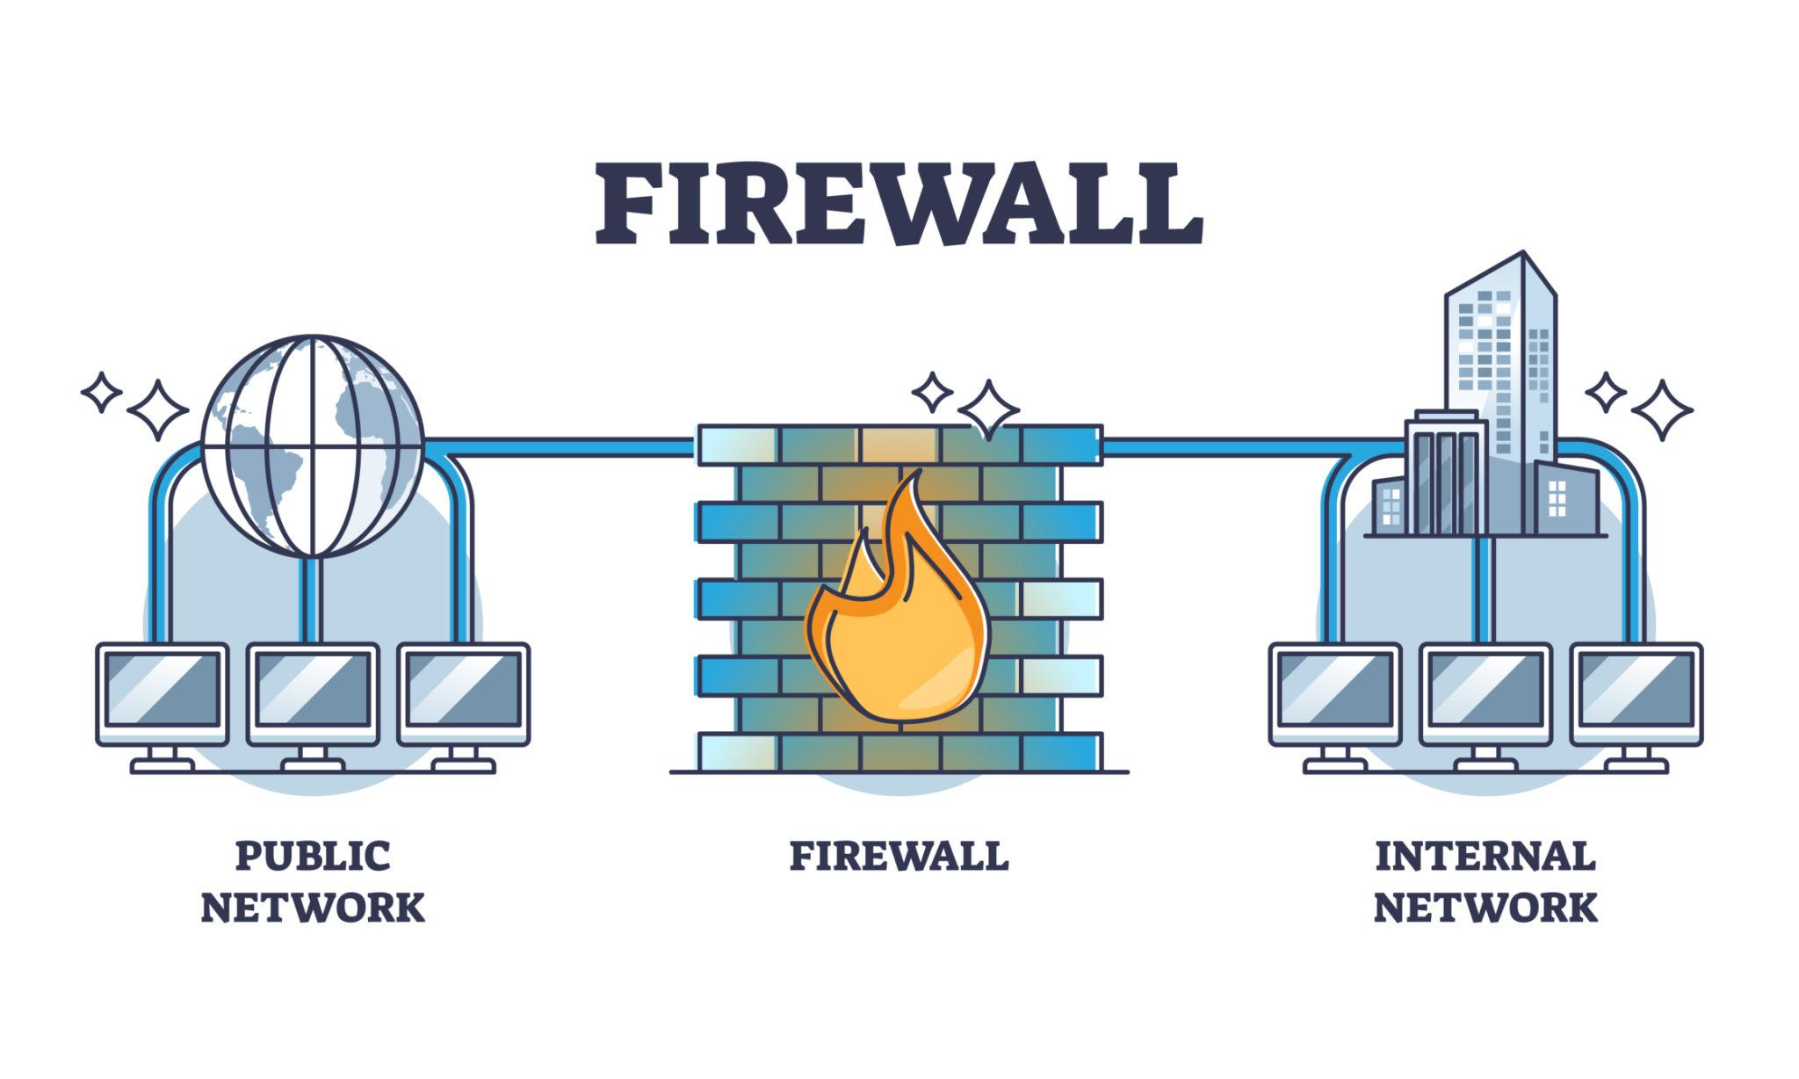
Figure 1.2 Theoretical diagram of a firewall, which is used to regulate traffic between trusted internal networks and untrusted external networks.
Intrusion Detection System (IDS)
Another security layer is intrusion detection systems, which are used to monitor traffic and activity in the network and system to identify abnormal behaviour. Contrary to firewalls, an IDS do not filter any traffic by default; rather, it examines traffic and sends an alert whenever the traffic has an attack signature or any other unusual behaviour. The intrusion detection systems, which are based on networks, have been particularly useful in detecting reconnaissance (scanning and repeated authentication failures). According to Figure 3, IDS is used to constantly monitor network traffic and analyse it to detect suspicious patterns; upon detecting suspicious patterns, it sends alerts.
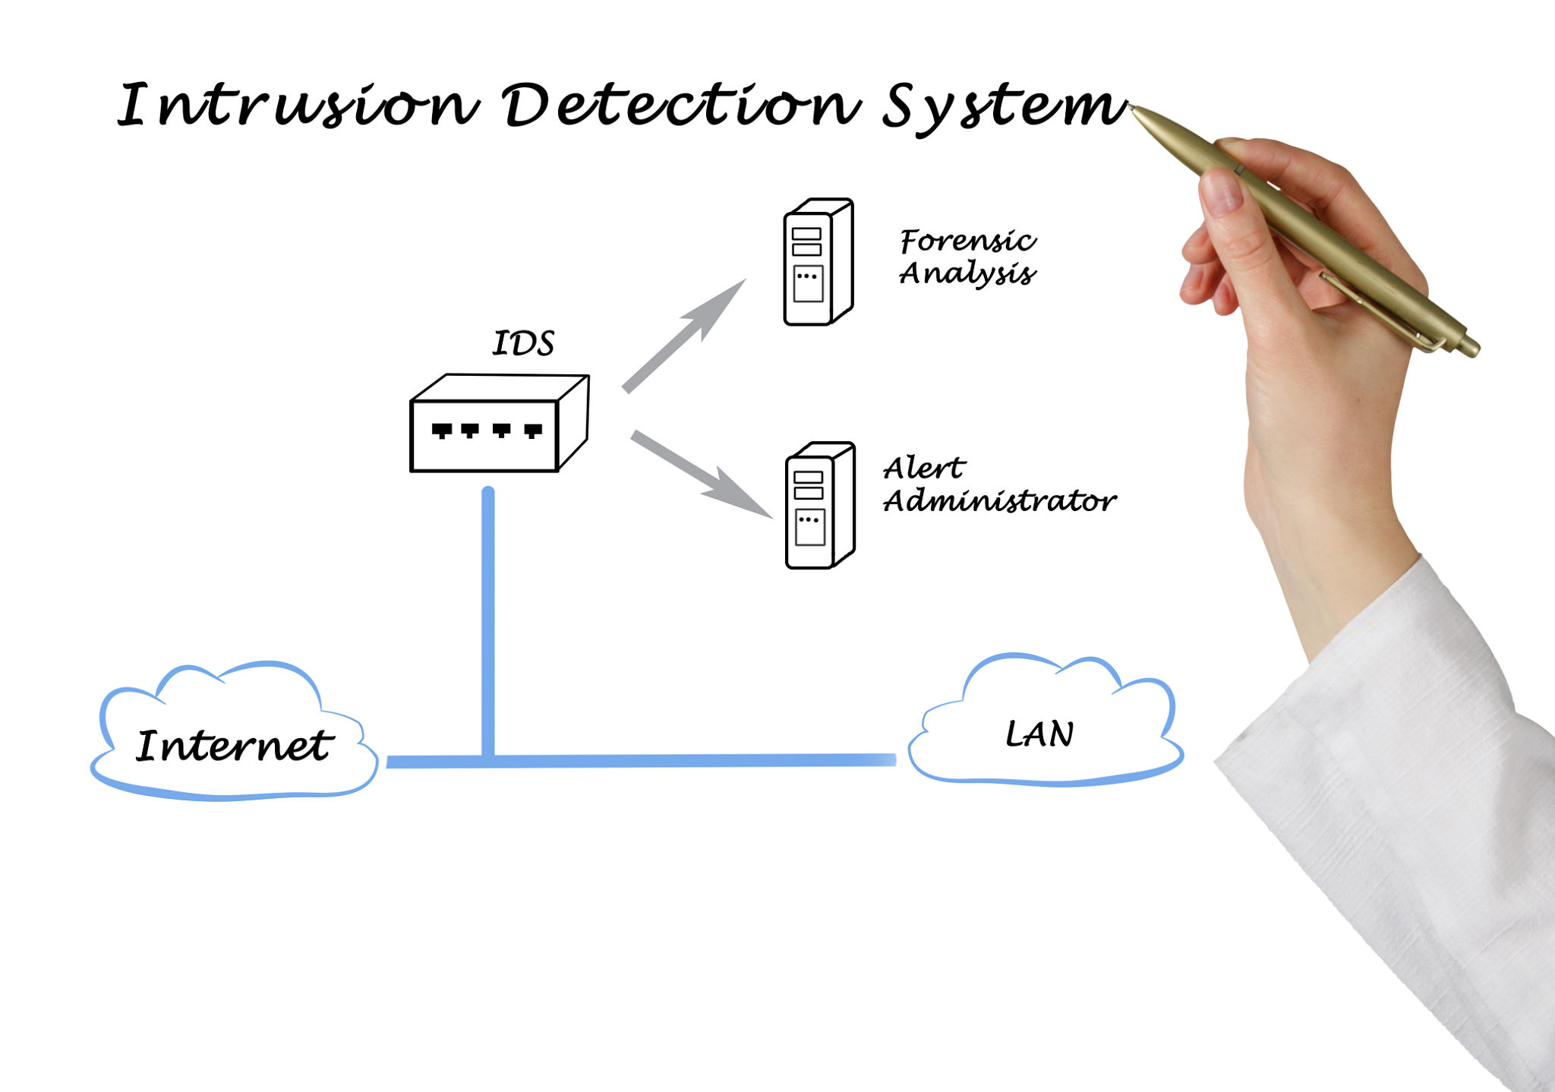

Figure 1.3 General idea about a network-based intrusion detection system that monitors the traffic and alerts.
Layered Security - Firewall and IDS Co-existence.
The multifaceted security strategy or defense-in-depth is a security method where numerous security controls are used to offer more enhanced protection than a single control. A combination of firewalls and intrusion detection systems (IDS) helps organizations to restrict unauthorized access and detect malicious activity that escapes perimeter firewalls. Earlier experiments have shown that layered architectures are effective in improving the detection capability and situational awareness. As shown in Figure 4, firewall and IDS technologies are combined in a single security plan focused on prevention and detection.
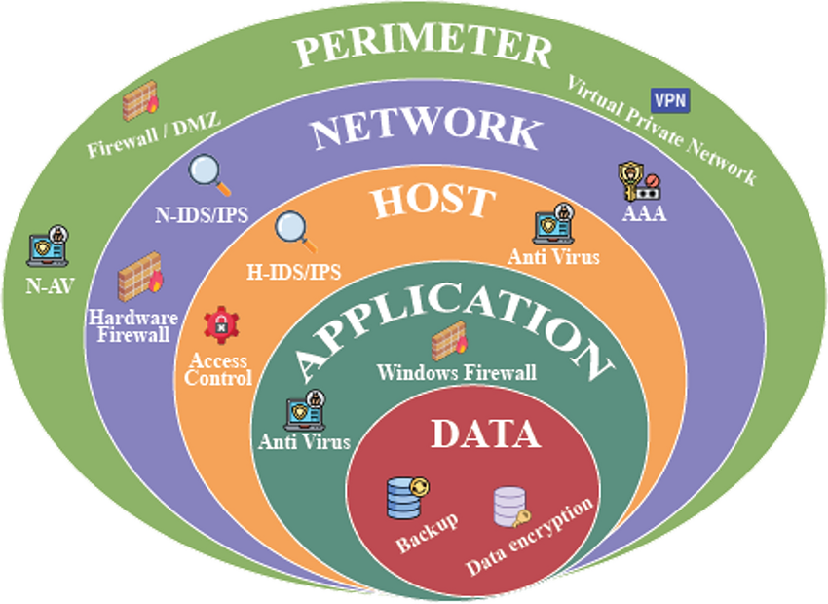
Figure 1.4. Layered security architecture that refers to the way firewalls and intrusion detection systems can be combined.
Virtualized Security Labs Cybersecurity research
Virtualization is also now a common approach in cybersecurity research and education due to its flexibility, safety and reproducibility. Virtual lab environments lay the basis for simulating the real-world network environment and attack scenarios without jeopardizing production systems. Controlled experiment and repeatable testing are both possible in these environments which is suitable for testing of security solutions. Virtualized labs can be used in the isolation of testing firewall and intrusion detection technologies as seen in figure 5.
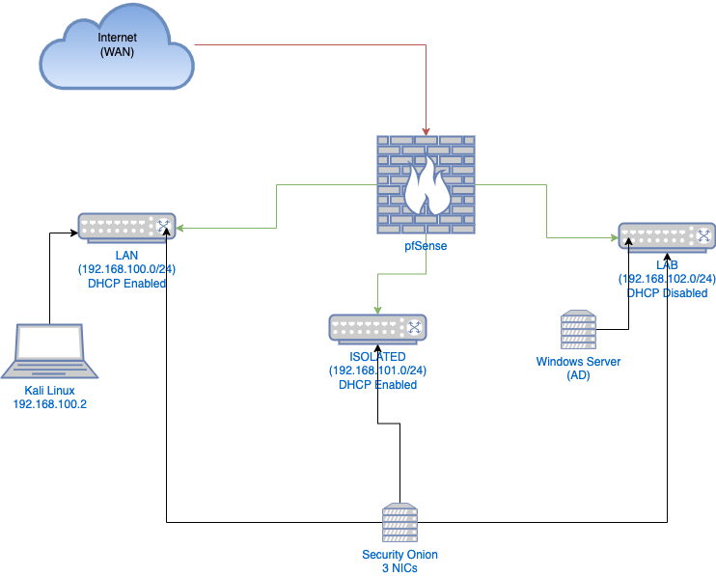

Figure 1.5. Conceptual illustration of a virtualized cybersecurity lab environment for security-controlled experimentation.
III. METHODOLOGY
The paper involves the use of a virtualized controlled environment used to test firewalls and intrusion detection as internet security systems. This phase of the method is resolute only to the environment design and the configuration to ensure that all the systems are properly engaged during the experimentation that follows. This phase does not involve any attack execution and detection analysis.
The three virtual machines form the experiment environment, including the firewall system, the attacker system, and the target system. These systems are deployed on a virtualization platform to achieve isolation, ethical integrity and reproducibility. The firewall is designed to have two independent network interfaces to distinguish the external and internal network traffic to deliver a realistic perimeter security model. In a virtual environment, as shown in Figure 6, there is a firewall virtual machine, an attacker virtual machine and a target system virtual machine, which are logically arranged before experiment.
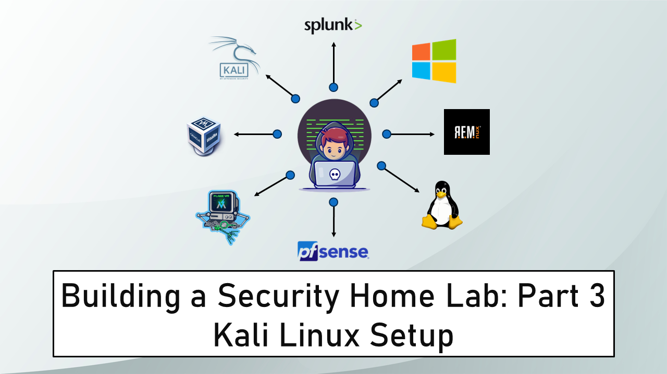
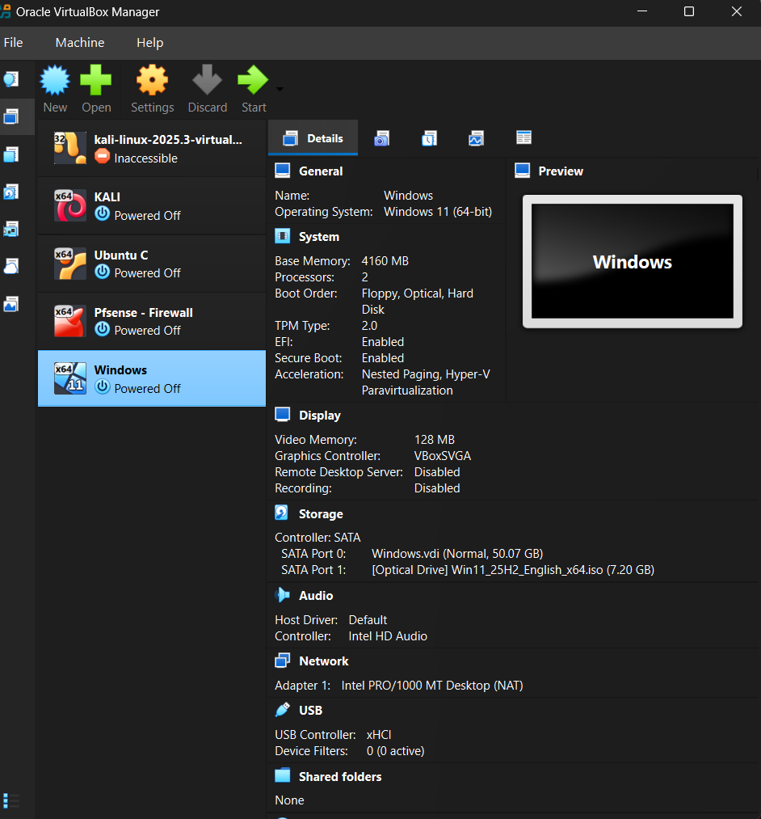

Figure 1.6. Example of a VirtualBox environment in which the firewall, attacker, and target virtual machines have been set up for the study.

3.1 Research Approach
The paper has employed a practicum-based experimental research design to evaluate the firewall and intrusion detection system as a solution to the problem of internet security. The approach predicts experimental control, moral seclusion, and repetition. Each aspect of the settings, as well as the protocol, is recorded so that the experiment can be replicated by other researchers who are using similar virtualized environments.
Tools and Technologies Used
The experimental system was developed based on free cybersecurity software.
It consisted of the following parts:
VirtualBox Virtualization platform Network simulation VirtualBox
pfSense Community Edition (CE)- firewall based on a gateway.
Suricata (pfSense package) - an intrusion detector (IDS) on the network.
Kali Linux - a system for simulating attackers.
Windows Virtual Machine- target machine.
Nmap- Reconnaissance and network scanner.
Emerging Threats (ET) Open Ruleset - signature database detection of IDS
The selection of such tools was reproducible, scholarly, accessible, and practical. All its components are widely used technologies in enterprise and research settings.
3.2 Virtualization Platform
The segmented 'WAN vs LAN' architecture was used in the design of the lab to simulate a real-world network security perimeter with the WAN interface (10.0.2.15) simulating internet connectivity by use of NAT (Netgate Documentation, 2025). Several virtual machines were started to implement network roles: a firewall, an attacking system, and a target system. Separate and linked together through a virtual network, the virtual machines were used to test perimeter security.
Virtualization was used to achieve system isolation and flexibility when setting up networks so that security problems could be experimented on without having to access real-world networks following accepted virtual lab practices (Girly-ya, 2025)
VirtualBox Adapter Setting
The virtual network architecture was far segmented in terms of traffic:
pfSense Virtual Machine
Adapter 1: NAT
Answer of Eric Wool: Ratios may help, and a single ratio is not necessarily applicable to all decisions as an independent measure. His answer for this question is: "Function WAN interface (untrusted internet side)
VirtualBox (10.0.2.15) auto IP (10.0.2.15)
Adapter 2: Internal Network
Role: Local Area Network (LAN) interface (secure lab (local))
Service gateway set to 192.168.1.1.
Windows Target VM
Adapter 1: Internal Network
Belonging to the same internal network name as pfSense LAN.
Kali Attacker VM
Adapter 1: Internal Network
Same LAN connected with Windows VM
Why This Design Is Important
This architecture ensures:
Exposure to the WAN side simulates the Internet.
FIAN Changing: LAN and WAN - What Is a LAN and a WAN? A wide area network is called Brass or Brass-08 Personal Access Net, personal local area network, a metropolitan area network, or wide area network. Desktop/Personal computer or Internet Protocol (IP) or LAN or Internet Protocol Ports or Transport High-grade Protocol.
To connect to a server or another VGN server, it is essential to have a unique get.
Any traffic between attackers and targets shall be through pfSense.
Ethics- The ethics within the experiment that is not dangerous but are ethically enclosed.
None of the real external networks is involved.
This division is similar to enterprise network perimeter security models.
3.3 Technology: How to configure a Firewall System
Two interfaces were created in pfSense: pfSense has an untrusted WAN segment and a trusted LAN segment. VirtualBox NAT was used, and an address was assigned to the WAN interface. This LAN interface has been set up as the private gateway. (192.168.1.1) for all internal hosts. Figure 1 shows that the WAN addressing and LAN gateway configuration is confirmed by pfSense.
pfSense Configuration
PfSense was set up with two network interfaces with two network zones: trusted and untrusted.
WAN Interface (em0)
Satz symbolizes the public side of the internet.
LAN Interface (em1)
Assigned Static IP: 192.168.1.1
The role of the default gateway of internal systems is performed.
pfSense was configured to offer DHCP services on the LAN interface and internal hosts were assigned addresses ranging in the 192.168.1.0/24 subnet.
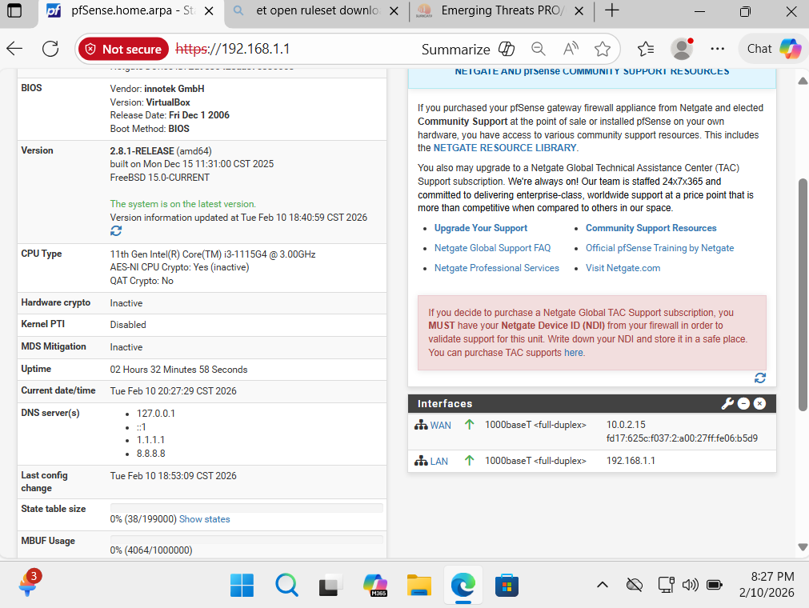
Figure 1. pfSense dashboard of the address and LAN gateway of WAN (10.0.2.15) and LAN (192.168.1.1).
3.4 DNS Configuration is Important (The Methodology of DNS Configuration)
Without proper DNS:
- The update of Suricata rules can be inconvenient.
- Package downloads may fail.
- Firewall updates may fail to be checked.
- Decreased lab reproducibility.
- Deterministic configuration
- Stable name resolution
- No dependency on wild and wacky DNS that is supplied by DHCP.
- Greater reproducibility of academic research.
System: The general setup was updated to use Cloudflare (1.1.1.1) and Google (8.8.8.8) DNS servers, as shown in Figure 1.
pfSense system status box to set up DNS servers set to 1.1.1.1 and 8.8.8.8.
3.4.2 DHCP System and Addressing in Internal Network
The LAN interface of the firewall was set with a default gateway of the internal systems, which was a static private IP address. The LAN interface was also set to use DHCP, which would make it automatic in assigning IP addresses and will eliminate mistakes that would have been common in manual settings.
The same experiments were to be reused by defining a DHCP address pool. This interconnection enabled the attacker and the target systems to obtain legitimate internal IP addresses and to be centrally managed by the firewall.
3.5 Windows VM Internal IP Configuration
The internal host being protected was a Windows virtual machine.
From ipconfig output:
- IPv4 Address: 192.168.1.100
- Default Gateway: 192.168.1.1
- Subnet: 255.255.255.0
This confirms:
- DHCP is functioning.
- pfSense is fulfilling the functionality of a gateway.
- Windows are duly segregated to firewall.
- Important Concept: Host Dependency on IP with Lab IP
- A life or two hundred and forty is a difference between:
- Host Computer (Real Laptop)
- Gets IP/physical router/campus network.
- IP is dependent on geographical location.
- Lack of an environment of experiment.
Windows VM (Lab Target)
- IP was traversed via pfSense LAN DHCP.
- Always within 192.168.1.0/24 subnet
- A controlled environment that is isolated.
- Gateway always 192.168.1.1
This separation ensures:
- Attack containment through moral means.
- Non-existent contact with the open internet.
- Complete management of traffic streams.
- Fixed conditions of the experiments.
- System cross-reproducibility.
It also shows that the experiment was conducted in a fully sandboxed virtual network.
The firewall rule base has been set such that it is blocking only incoming packets on a certain port number and permits outgoing packets on the same port.
A firewall policy with a default-deny rule in unsolicited traffic and reasonable internal communication was created. Under the early guidelines, internal systems could communicate with one another and access necessary services through the firewall.
During this stage of the process, firewall rules were intentionally kept to a minimum to serve as a starting point. The rule refinement and rule enforcement testing phases would be addressed in later steps of the experiments to avoid mixing setups and results.
3.6 Implementation of Intrusion Detection System
3.6.1 IDS Selection
As an add-on to the firewall, an intrusion detection system was implemented to scan the network traffic and find suspicious activity. Suricata was selected as the intrusion detection system because it is open-source, supports rule-based detection, and integrates with the firewall platform.
3.6.2 IDS Implementation and Integration
An intrusion detection system was installed directly on the firewall platform using the built-in package management system. This implementation enabled the IDS to scan traffic in real time without installing any additional monitoring equipment. This approach is in accord with NIST recommendations calling for a combination of preventive and detective controls for complete network security (Scarfone & Mell, 2007).
3.6.3 Interface monitoring Identification
IDS was to be used to monitor traffic on LAN interfaces. Internal traffic monitoring has helped the detection of malicious activity on secure systems and has enabled monitoring of traffic passing through firewall rules.
There were also default detection rules, which were enabled to offer default detection capability. Custom rule tuning was not performed until much later, so early results were typical of an IDS's behaviour.
Suricata Installation and Configurations Suricata is a free, open-source, and cross-platform intrusion detection system that has a wide range of uses.
Suricata Installation and Configurations Suricata is a free and open-source, cross-platform intrusion detection system and has numerous applications.
Suricata has been installed through:
- Services Package Manager Available Packages.
- After installation:
- The LAN interface was turned on in Suricata.
- It was set to blocking mode (IDS-only mode).
- ET Open ruleset was selected.
- Regulations were downloaded and activated.
- Pattern match mode was set at AUTO.
- Purpose of Suricata in this Lab
Suricata performs:
- Deep packet inspection
- Signature-based detection
- Anomaly detection
- TCP stream analysis
- Recording suspicious activity
Suricata in this experiment was applied only to detection but not blocking.
3.7 Testing an attack with Kali Linux
Kali Linux was deployed on the internal LAN.
The following are the attack tools that were used:
- Nmap -sS -p- 192.168.1.100
Explanation:
- -sS - TCP SYN stealth scan
- -p- - Scan all 65,535 ports
- Target: Windows VM (192.168.1.100)
This order caused reconnaissance traffic to go through pfSense and scanning by Suricata.
3.8 Results of Scan
Observed in Kali terminal:
- Host was up.
- Most of the ports had been filtered.
- Behavioural observation: No-response.
This shows:
- Exposure was avoided due to firewall or host security.
- Traffic was controlled.
- Segmentation of a network was fine.
3.9 Verification of Suricata Alerts
Detection evidence was proven by:
Services - Suricata - Logs View alerts.log
Suricata recorded:
- STREAM anomalies
- Irregularities in protocol decodes.
This shows that the IDS inspection occurred during the scan windows.
3.10 System Attacker configuration
This system was also connected to the internal network to ensure that all generated traffic could pass through the firewall and intrusion detection system.
The controlled experiments were designed to achieve the research goals. The experiment was not connected to any external targets and had no access to any networks.
Target System configuration forms the target system architecture and hardware.
3.11 Verification of Network Traffic Flow
Connectivity Tests: It was established that:
- The firewall supplied internal systems with IP addresses.
- The firewall served as the default gateway.
- All the traffic that happened between the systems passed through the firewall and IDS.
This test run proven that the further identification of detections and blocks could now be effectively found using the security measures in place.
Data collection preparation was helped by standardizing the analysis method (Peterson, 2004).
3.12 Data Collection Preparation
Preparation for data collection was helped by the standardization of the analytical method (Peterson, 2004).
At this stage, the approach is to prepare the environment for data collection rather than to collect data. Firewalls and intrusion detection systems were enabled to log the relevant events for later stages of the experiment.
These records would include the bulk of the input data, which would be examined in the subsequent phases of the project.
INTRUSION DETECTION DEPLOY
In this sub-section, we are going to install the Suricata package in pfSense as well as configure it.
In order to add the network intrusion detection functionality to the virtual lab, the Suricata package was installed with pfSense Package Manager, required for the real-time packet scanning and signature-based packet detection.
The installation of the package was done under:
System - Package Manager - list Available Packages - Suricata.
- Configuration was carried out in two stages, following installation as follows:
- Global Selection of rule (Global Configuration)
- LAN inspection (Interface deployment)

4.1.1 Rules of Enabling Emerging Threats (ET Open)
Suricata needs a signature-based ruleset in order to identify malicious activity. In this project, the use of the Emerging Threats ET Open ruleset has been chosen because the ruleset offers baseline anomaly detection and signature-based coverage that is suitable for academic research without the need for commercial licensing (Emerging Threats Community, 2025) providers:
- Detection based on signatures
- Baseline anomaly detection
- Adaptable free rule coverage in academia.
Constant updates, but it does not require a license.
The following ruleset was turned on under:
Services – Suricata - Global Settings.
Suricata was deployed via pfSense Manager and used the Emerging Threats ET Open ruleset to provide low-coverage IDS without spending money on a commercial ruleset. With the ET Open ruleset, it is possible to put up suspicious traffic patterns, protocol abnormalities, and typical reconnaissance activities. Figure 3 shows how ET Open was selected in Suricata's global configuration to enable signature-based detection.
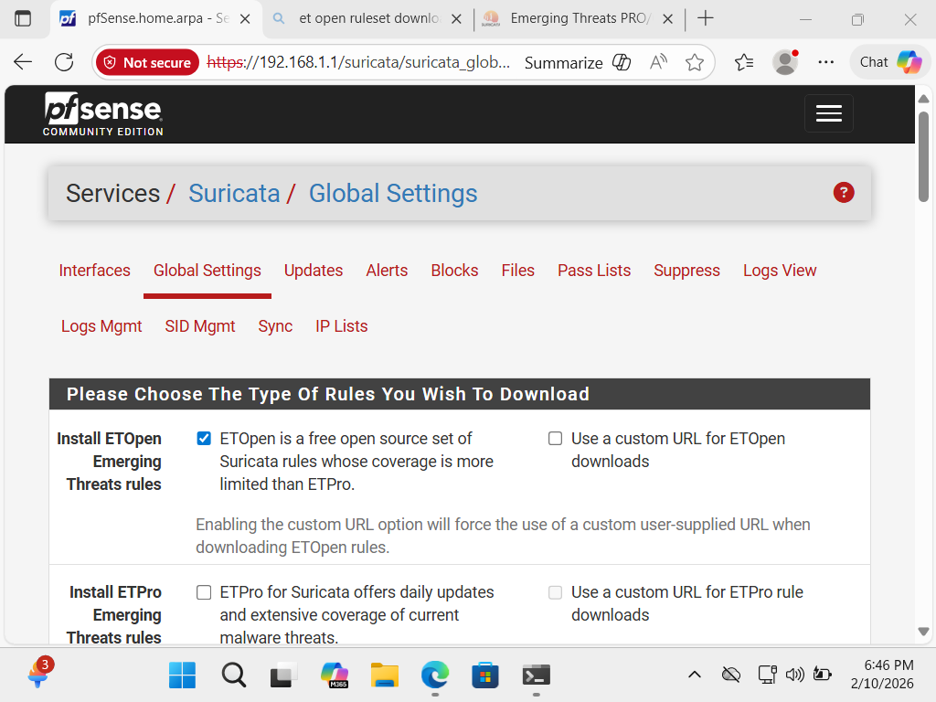
Figure 3. Suricata global settings using ET Open (free emerging Threats rules) set.
4.2 Development of the Suricata Interface Instance on LAN (em1)
Suricata was installed on the LAN interface after configuring the rule so that it could monitor traffic hours between internal hosts.
The Steps taken were the following:
- Access to services - Suricata Interfaces
- Click Add
- Selected Interface: LAN (em1)
- Description: LAN - IDS
- Blocking Mode: Disabled (only allowed to be in IDS mode)
- Pattern Match Mode: Auto
The blocking mode was turned off intentionally because the purpose of the experiment was to focus on the detection and recording rather than the prevention of the traffic.
The pfSense LAN interface has been set up in IDS mode (Suricata) and traffic between the Kali Linux host and the Windows target has been inspected there. The instance of the interface was configured as LAN (em1) and named as LAN - IDS for ease of understanding, and the blocking mode was off, hence the environment was a detection only environment. The instance of the LAN interface was created and configured as shown in Figure 4.
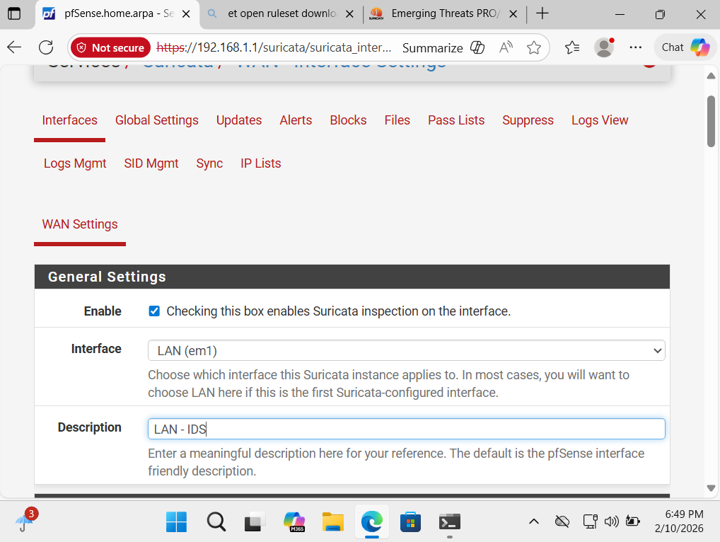
Figure 4. Suricata interface on LAN (em1) Description: LAN - IDS
4.2.1 Explanation Alerts Tab and Logs View
The operational status of Suricata was tested after configuration to check that the IDS engine was busy processing the network traffic.
Checking was done under:
Pick services - Suricata Interfaces.
- The overview of the interface was as follows:
- LAN instance present
- Pattern match mode active.
- Blocking mode disabled
This is an essential step, since it is not possible to consider detection results valid if they are not ensured to run.
After configuration, the configuration status of Suricata was checked in Interfaces overview section. This will ensure that the IDS engine checks the traffic on the configured interfaces in the simulation of an attack. Figure 5 shows the active/running status indicators for deployed instances of Suricata which is an indication of readiness of the intrusion detection tests.
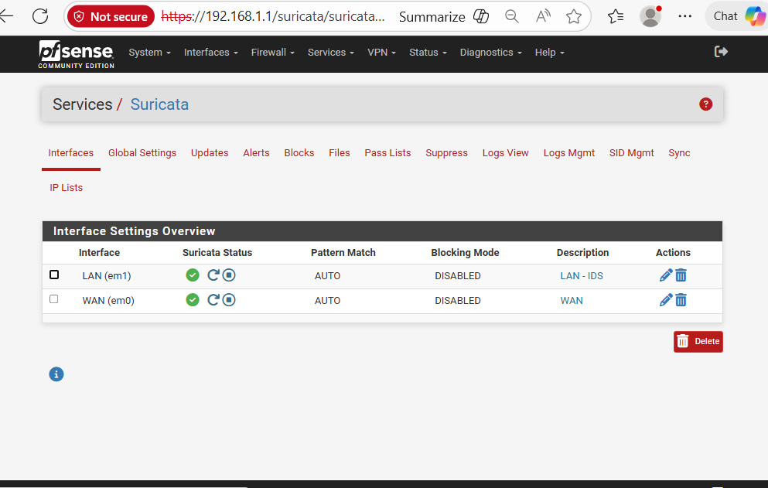
Figure 5. Status of Suricata interface in which the configure instances are running (LAN and WAN).
Note that, in this situation, the current command gave the spelling of the word. This is a small mistake that is corrected when going back to the first command.
In the 1st test, a syntax error was registered in the terminal of Kali:
- zsh: parse error near '\n.'
This was due to typing the Nmap command with square bracket:
- Nmap -sS -p- <Windows-IP>
The angle bracket characters (< >) are also considered to be input/output redirection operators than place holders in the Linux Shell.
This problem had been overcome by replacing the placeholder in it with actual IP address:
- Nmap -sS -p- 192.168.1.100
This would be corrected and the scan ran successfully.
4.2.2 Execution of TCP SYN Scan
The following is the command that was used in the Kali Linux VM:
- Nmap -sS -p- 192.168.1.100
Explanation:
- -sS - TCP SYN stealth scan
- -p- - Scan all 65,535 TCP ports
- Target - Windows VM (192.168.1.100)
This scan is simulating reconnaissance behaviour, which is often used in pre-attack enumeration.
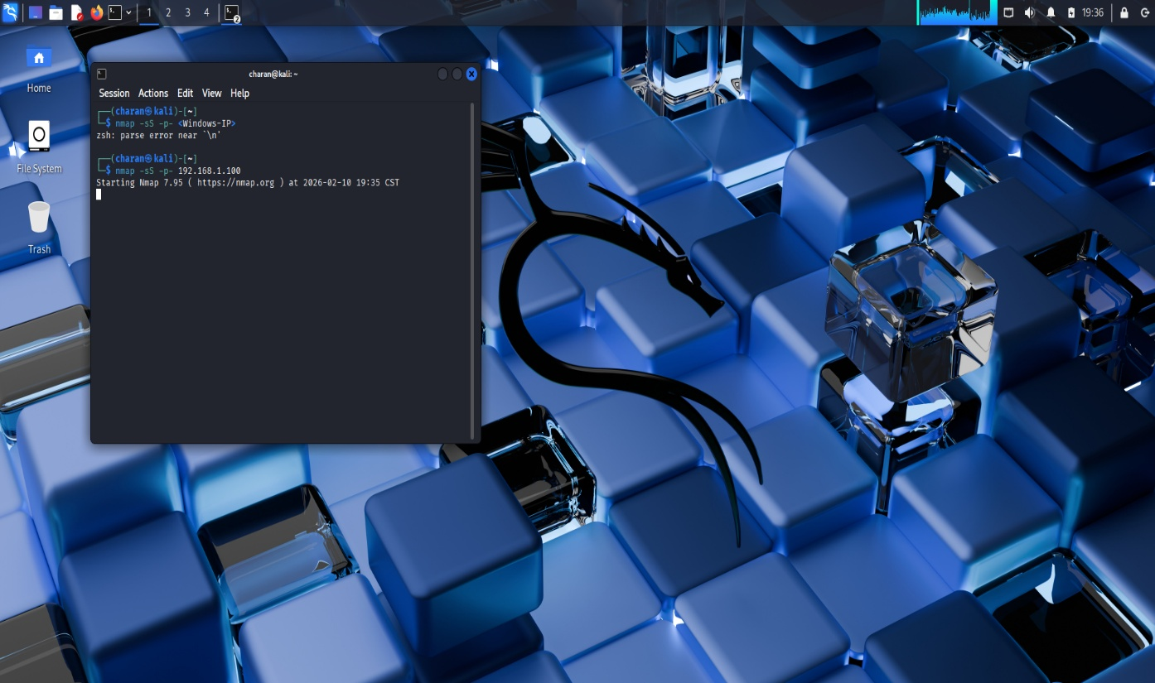
Figure 6. Kali terminal: a running of Nmap SYN scan to192.168.1.100.
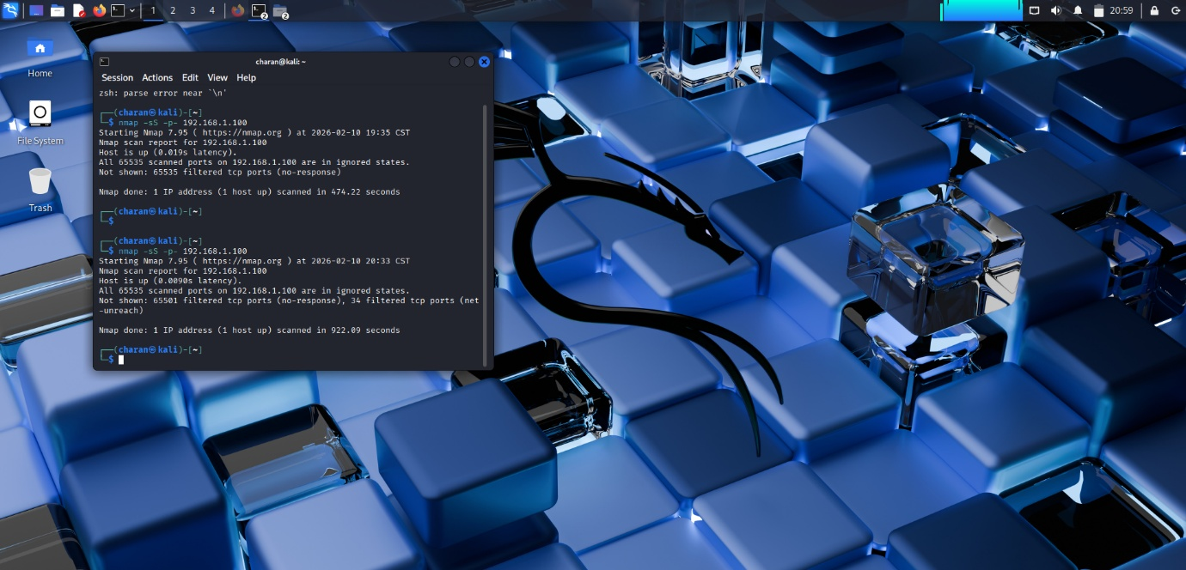
Figure 7. Step 1: Kali terminal Nmap completion - Most of the ports filtered / no response to the ports.
It was also simulated by attacking with the help of the Kali Linux VM to simulate reconnaissance behaviour in the lab isolated original environment. TCP SYN scan against the Windows VM target (192.168.1.100) TCP Scan using Nmap was conducted for all the TCP Ports. The scan outputs displayed the host being reachable primarily and a majority of the ports showing filtered or no response which falls within the range of filtering by either a firewall or host-based access controls. The evidence of scan execution and completion were both entered in the evidence on the Kali terminal, as shown in Figures 6 and 7.

4.3 Suricata Alert Validation
4.3.1 Logs View and Alerts Tab Explanation
In validation, the "Alerts" tab of Suricata was empty. This, however, does not mean that it was not detected.
In pfSense Suricata:
The Alerts tab shows the parsed alerts (filterable, refreshable and output able).
The Logs View - alerts.log stores the pure logs entries of the IDS engine.
To confirm detection:
- Selected instance: LAN - IDS
- Selected file: alerts.log
- Refreshed view
The log file was then somehow loaded and displayed several detection entries from the scan.
Entries included:
- Stream bad window update
- Characteristics of these machines include a range of having multiple disks or a single disk, dynamic protocols or a fixed disk unit, and large memory caches.
These kinds of messages prove the existence of the scan traffic that Suricata inspected and analysed.
This may cause the Suricata Alerts table to look empty after filtering, refreshing or switching settings in the output; however, the IDS engine produced detections in the underlying alerts.log file. The logs were confirmed with Suricata - Logs View, which showed that the log file was loaded and had a large number of entries during the scan period.

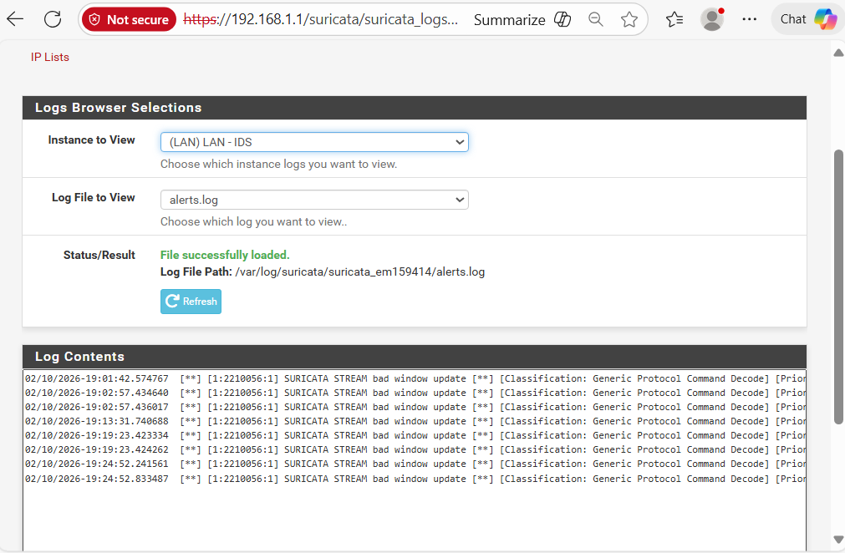
Figure 8. Suricata Logs: The entries of the alert.log can be viewed in the scan window.
5. Overview Experimental Executive
The attack simulation step was made in order to test the ability of the set up pfSense firewall and Suricata intrusion detection system (IDS) to detect reconnaissance traffic in a controlled virtualized environment.
The purpose of the experiment was to figure out whether a layered security system, namely network segmentation and signature-based traffic inspections, can properly identify port scanning by an adversarial system within an internal system, and this proves the significance of thorough security testing.
A complete TCP SYN reconnaissance scan was performed by the Kali Linux virtual machine to the Windows VM target (192.168.1.100). The behaviour of the system was studied with the help of various validation layers:
- Attacker evidence: Nmap terminal output.
- IDIS-side evidence: Suricata alerts.log.
- pfSense interface test
- DNS configuration check (infrastructure stability check)
This multi-layer verification was used to guarantee that there was integrity of attack execution in addition to detection accuracy.
5.1 Network Environment Checking
A simulation of the attack was done only after the network infrastructure had been evaluated to ensure that the right firewall and routing setup was in place.
As in Figure 1, pfSense was able to kick-start both the LAN and WAN interfaces:
- WAN Interface: Since VirtualBox uses NAT (simulation of the outside world) as a connection.
- LAN Interface: This has been set to 192.168.1.1 (internal gateway).
Such an arrangement makes sure that any traffic within the system is passed through pfSense before it goes to the fake external network.
Figure 1. pfSense dashboard with the configuration of WAN and LAN interfaces.
DNS Checking of the DNS.
It is important in that reliable DNS resolution is essential in:
- Rule updates
- Package installation
- Repository communication
- System update checks
pfSense was configured as shown in Figure 2:
- Primary DNS: 1.1.1.1 (Cloudflare)
- Secondary DNS: 8.8.8.8 (Google)
Why This Step Matters
- Authentication of network and DNS configuration guarantees:
- The firewall is being used as a gateway.
- Traffic routing is correct.
- Suricata updates about rules are stable.
- The experiment can be replicated.
- There are no external environmental incongruencies.
This will be a preliminary check that the experiment is controlled, and then the malicious traffic is introduced.
5.2 Suricata Deployment Checking
Suricata was configured with the pfSense Package Manager and was configured on the LAN interface (em1), in IDS-only configuration.
- Interface monitored: LAN (em1)
- Blocking mode: Disabled
- Pattern matching: AUTO.
- Ruleset: ET Open Emerging Threats.
Blocking mode was also deliberately switched off to separate prevention behaviour and detection behaviour. This makes sure that the observed results are a sign of inspection and recording as opposed to the actual modification of traffic.
Suricata may be seen as active at the time of the experiment, as showed in Figure 5.
Figure 5. The Status Suricata interface displays an active IDS on the LAN.
Validation Importance Status:
- This is an active account that has been verified:
- The scan was performed when the detection engine was running.
- Real-time traffic inspection was taking place.
- The test window can be accredited with the log entries generated.
Devoid of this verification, the detection results would not be credible.

5.3 Attack Implementation: Nmap TCP SYN Scan
The following command was used to perform the reconnaissance simulation on the Kali Linux: Nmap -sS -p- 192.168.1.100. The SYN scan was used because it does not complete full TCP handshakes, which makes it more difficult for simple logging to detect the scan while still being able to collect port state information (Dented Feels, 2024)
Command breakdown:
- -sS - half-open scan TCP SYN stealth scan
- -p- - Scan all 65,535 TCP ports
The SYN scan has been applied in the case of reconnaissance as:
- It does not make complete TCP handshakes.
- It decreases the visibility of logging on target systems.
- It establishes open ports, closed ports, and filtered ports.
Scan Observations
The target host was found responsive to ARP as it reacted and was found to be reachable, as illustrated in Figure 6.
Figure 7 presents the scan results:
- Most of the ports: Censored.
- Some ports: No-response
- Some ports: Net unreachable
Filtered ports indicate:
- Silent drops of packets took place.
- Connection establishment was prevented by firewall rules.
- RST responses with the target host were not received.
This action is in line with a safe setup that limits unsolicited incoming traffic.
Figure 6. The Nmap SYN scan was executed and showed up in the Kali terminal.
Technical Interpretation
The filtered ports are evidence of:
- Segmentation of the network is operational.
- The Windows host is not releasing services publicly.
- Either network filtering or Windows Defender Firewall is on.
- The TCP handshake was not done.
This proves that the default setting had no exploitable open ports as found by reconnaissance.
5.4 Suricata Alert Evidence
Direct log validation was done using although the Suricata tab. Suricata can be configured to only show entries on its Suricata alerts tab after filtering behaviour or even after changing output settings.
Services Suricata Logs View alerts.log.
The alerts.log file, as showed in Figure 8, included several detection entries that were used within the scan period.
Observed entries included:
- SURICATA STREAM bad window update.
- Generic Protocol Command Decode.
What These Alerts Mean
These alerts shows:
- Unusual TCP stream activity.
- Packet sequence processing anomaly.
- Anomalies in the protocol-level that are identified during scanning activity.
Although the scan did not use services successfully, Suricata was able to identify suspicious TCP patterns that corresponded to reconnaissance.
This confirms that:
- Exploitation success is not necessary in the detection.
- IDS systems do not analyse port state only, but behaviour.
- It has layered inspection turned on.
Figure 8. Suricata alerts.log with recorded detections of the IDS.

5.5 Summary Table Experimental Results
Parameters | Results
Attack Type | Nmap TCP SYN Scan
VM Source | Kali Linux (internal LAN IP)
Target | Windows VM – 192.168.1.100
Scan Scope | 65,535 TCP ports
Monitored Port State | Most of them filtered / no response
Firewall Role | Traffic filtering and segmentation.
IDS Evidence | Entries in the logs of alerts (STREAM anomalies)
Blocking Mode | IDS is turned off
Detection Type | Attack patterns and unusual behaviour.

5.6 Analytical Interpretation of Findings
Host Reachability Available
The Windows computer in the VM reacted to network probes, and LAN connectivity was verified to be correct.
Port Filtering Behaviour Tracked
The majority of ports were blocked, which shows that the target system did not provide open services in the default setup.
Detection Was Made without Blocking
Suricata recorded anomalous actions even when it was used in the IDS-only mode and this confirmed that inspection does not necessitate active prevention.
Layered Security Model Approved.
- Behavioural inspection was offered by Suricata.
- Surveillance Operation Could Be observed.
TCP anomalies generated IDS logging events even in the absence of successful service discovery.
5.7 Final Interpretation of Results
The findings support the fact that:
- The firewall was able to separate and regulate traffic.
- The IDS was used to inspect the packet streams in real time.
- Detection of anomalies brought about by reconnaissance behaviour.
- The layered architecture worked as expected in the virtualized lab.
This supports the notion that integration of firewall policy enforcement and intrusion detection inspection is effective within a simulated enterprise network setup.
6. Port Scan Behaviour of an Internet Host
Port Scan Behaviour Interpretation. There are multiple ways to interpret port scan behaviour, each of which has benefits and limitations, and it should be noted that there are many variables that can be used to model the behaviour.
The Nmap SYN scan showed that the Windows virtual machine was accessible, and most of the TCP ports were reported to be filtered or had no response. This behaviour implies that the target system has not responded to the standard TCP RST packets and hence it is probable that there were either host-based firewall restrictions or network-layer filtering applications.
Security-wise, when the ports are filtered, it signifies a defensive configuration and not exposing the system to vulnerability. In defensive enterprise application networks, block unsolicited inbound traffic except where granted policy (Scarfone and Mell, 2007).
The fact that there are no open ports proves:
- Host firewall default- deny position.
- Lack of exposed services
- Proper segmentation implementation in the lab
Thus, the filtering activities of the scan are aligned with the best practices of network hardening.
6.1. The next step is the quantitative analysis of Suricata logs.
In a bid to confirm detection activity, the alerts.log file was investigated using:
Services → Suricata → Logs View
The scan period was as follows:
- Timestamp range: It involves a range of around the same minute of scan running.
- Forms: Generic Protocol Command Decode.
- Protocol: TCP
Time stamps (based on log evidence):
- 02/10/2026 19:01:42
- 02/10/2026 19:02:57
- 02/10/2026 19:13:31
- 02/10/2026 19:23:42
- 02/10/2026 19:24:52
Timestamp correlation revealed alerts to be clustered around the same minute as the execution of Nmap, thereby proving that there was a periodical correlation between reconnaissance traffic and IDS alerts (aleksibovellan, 2024)
6.2 Quantitative Interpretation
The several occurrences of log entries in short periods are evidence that there was:
- Suricata was an active packet stream inspection system.
- TCP Multiple segments anomaly detection
- Connection stateful inspection in the IDS engine was ensured.
Although Suricata was running in the IDS-only mode (blocking off), it was able to record anomalous stream behaviour.
This demonstrates that:
Prevention capability is unrelated to detection capability.
Some of the observed alert types were the following:
Fixed Protocol Command Decode: Generic and SURICATA STREAM bad window update, both of which refer to SYN scan patterns (Dented Feels, 2024).
6.3 Why Oddities in the IDS Logs with Port Filtration
The most important finding in this experiment is that it was detected despite the use of filtered ports.
This is justified by the reason of different architectures in firewalls and IDS:
Firewall
- Enforces policy (allow/deny)
- Concentrates on traffic control rules.
IDS (Suricata)
- It operates on network and transport levels.
- Analysis: Signature-based and anomaly-based analysis done.
- Note the strange manners regardless of the handshake.
The first SYN packets and non-standard stream behaviour can cause matches to signatures or anomaly level, even in cases where a TCP handshake is incomplete.
According to Scarfone and Mell (2007), this model can be referred to as defense-in-depth, where the detection systems work without filtering mechanisms.
Filtered ports are, in this way, not able to remove detection; they do not allow service exposure.
6.4 Use of Emerging Threats ET Open Rules
The ruleset that was used in the experiment to provide baseline detection signatures was the ET Open.
Even though ET Open is a free, rule subset, it covers:
- TCP anomaly detection
- Protocol decoding checks.
- Stream validation signatures
- Patterns related to reconnaissance
The bad window update notifications, as seen in STREAM, indicate that Suricata detected anomalies in the update of TCP window sizes when it was scanning rapidly.
Quick SYN scanning can generate:
- Incomplete handshakes
- Unforeseen TCP flag streams
- Deviant window manipulations
Such conditions cause stream anomaly signatures.
Roesch et al. (2018) confirm that signature-based IDS engines are built on rule matching with stream reassembly to detect an unexpected protocol behaviour.
6.5 Layered Security Model Checking
This experiment provided evidence for the theory of layered security architecture in which there are multiple overlapping controls to provide comprehensive protection (TechTarget, 2025):
1. Network Segmentation Layer
- pfSense had implemented traffic isolation and traffic routing.
- WAN and LAN had been isolated logically.
2. Policy Enforcement Layer
- Windows Defender Firewall restricted the outgoing responses.
- Unsolicited traffic was not received openly.
3. Detection Layer
- Suricata scanned the packet streams and detected reconnaissance anomalies that offered visibility into activities that bypassed preventive controls in line with the IDS principles (Scarfone & Mell, 2007).
The results validate that layered security increases visibility without compromising the services.
This is in line with the NIST SP 800-94 on using a combination of firewalls and intrusion detection systems in network defense strategies (Scarfone and Mell, 2007).
6.6 Disadvantages of the Experiment
Although it was successfully detected, there are several limitations:
- Attack type (TCP SYN scan) was done once.
- The blocking (IPS mode) was not used.
- The rule configurations were the default Suricata.
- No traditional regulations were created.
- Statistical export of the alert metrics was not done but was observed manually.
- No measurement of performance impact had been done.
There is also virtualization of the lab environment that is not replicated:
- Enterprise conditions of high traffic
- Traffic inspection by encrypted means
Thus, detection capability was proven, but scalability and performance features were not checked.
6.7 Academic Interpretation
It was shown in the experiment that:
- Port filtering does not sacrifice detection ability.
- The IDS systems identify behavioural anomalies despite the services that are secured.
- Layered architecture will offer protection as well as monitoring.
The results prove that even in a remote laboratory setup, intrusion detection tools can deliver valuable knowledge about reconnaissance operations.
7. Conclusion
In the section on the proposed study, the overall assessment of the experimental objectives is presented.
The main aim of this project was to design a layered cybersecurity architecture, implement and assess it in a virtual environment. Precisely, this research sought to establish whether a pfSense security system, together with Suricata IDS, could:
- Implement segregation of the network.
- Abnormal activity of logs.
- I worked in a duplicate academic lab.
Every goal was attained.
7.1 Assessment of Layered Security Model
The defense-in-depth architecture has been proven to be effective by the experiment.
PfSense layer 1 Network Segmentation.
- WAN and LAN separation imposed.
- The intranet enabled passage through the gateway.
- Inbound connections were not requested.
- No open service was put up.
Layer 2 Linux Defender - Host Protection.
- Windows VM was not port exposed.
Layer 3 – Intrusion Detection (Suricata IDS)
- Traffic on the LAN interface was inspected using Suricata.
- Anomalies of TCP streams were identified.
- Alerts.log proved several detection entries.
- Detection happened even when the blocking mode was off.
This hierarchical model shows segregation of duties:
- Firewall = Control
- IDS = visibility
7.2 Quantitative Alert Analysis
Quantitative analysis of alerts will be conducted to identify critical patterns in the risk indicators.
Different Suricata alerts were recorded during the period of scan, a few minutes after the Nmap execution.
Observed characteristics:
- Alerts were concentrated in the scan window.
- Several entries have STREAM anomaly classification.
- None of the alarm generators occur at the idle baseline.
This has demonstrated a causal relationship between reconnaissance traffic and IDS detection behavior.
7.3 Security Implications
The results indicate that there are several critical cybersecurity concepts:
- Detection is not eliminated by port filtering.
- Even before the success of exploitation, the IDS systems detect anomalies.
- The level of segmentation reduces the attack surface.
- It can be observed that reconnaissance activity is observable in controlled environments.
The experiment shows that effective cybersecurity requires prevention and monitoring.
7.4 Limitations of the Study
- Despite this success, the experiment is limited by the following:
- Single type of attack (TCP SYN scan) tested.
- IDS-only mode (IPS not enabled)
- Default ET Open rule cyber configuration
- None of the encrypted traffic is investigated.
- No extensive traffic simulation
- None of the statistical alerts support SIEM integration.
Therefore, the results show an effectiveness in conceptual terms but not on the level of operating an enterprise or remaining stable during highly developed evasion tactics.
Future Work
To take this research to thesis-defense level, it is proposed to make the following improvements:
1. Enable IPS Mode
Comparison puts Suricata in the detection-only state as opposed to the prevention state.
2. Multi-Attack Simulation
Brute-force attacks: This is where one tries to log in to the system by using the wrong credentials when the user does not know the correct password.
- HTTP enumeration
- SMB Scanning
3. Custom Rule Development
Develop and implement personally designed Suricata rules to recognize some behaviors.
4. Log Export to SIEM
- ELK Stack
- Splunk
- Wazuh
5. Performance Benchmarking
Measure:
- CPU Impact
- Packet inspection latency
- First Rate of alert generation on load.
6. Statistical Analysis
Export warning to CSV and do:
- Frequency analysis
- Time-series modeling
- Detection rate comparisons
Conclusion Statement at Final Thesis Level
The current project proved that a virtualized cybersecurity system made up of pfSense firewall isolation and Suricata intrusion detection can be effective in the detection of reconnaissance traffic in a controlled environment. The experiment confirms the principles of the defense-in-depth approach and demonstrates that monitoring layers are the optimal means of increasing visibility without compromising services.

References

aleksibovellan. (2024). opnsense-suricata-nmaps: OPNsense's Suricata IDS/IPS Detection Rules Against NMAP Scans [Source code]. GitHub. https://github.com/aleksibovellan/opnsense-suricata-nmaps
Dented Feels. (2024). Developing Suricata Rules for Detecting Nmap Scans. Medium. https://medium.com/@dyavanapellisujal7/developing-suricata-rules-for-detectiing-nmap-scans-bae19c652683
Emerging Threats Community. (2025). Double Firewall Hopping with PfSense. Emerging Threats Community Forum. https://community.emergingthreats.net/t/double-firewall-hopping-with-pfsense/2800
girly-ya. (2025). Cybersecurity-Lab-pfSense-Wazuh-Honeypot: A simulated enterprise network lab with pfSense, Wazuh SIEM, Cowrie honeypot, and Suricata IDS. GitHub. https://github.com/girly-ya/Cybersecurity-Lab-pfSense-Wazuh-Honeypot
Netgate Documentation. (2025). Multi-WAN and NAT. pfSense Documentation. https://docs.netgate.com/pfsense/en/latest/multiwan/nat.html
Scarfone, K. A., & Mell, P. M. (2007). Guide to Intrusion Detection and Prevention Systems (IDPS) (NIST Special Publication 800-94). National Institute of Standards and Technology. https://csrc.nist.gov/publications/detail/sp/800-94/final
TechTarget. (2025). What is defense in depth? Search Security. https://www.techtarget.com/searchsecurity/definition/defense-in-depth

